Single Data Loader: Extracting Salesforce records in .CSV format

**To extract the Salesforce records into .CSV format, follow the below steps:**

1. Begin the process by navigating from the AutoRABIT homepage to **DataLoader > DataLoader**.
2. Click **Extract** on the right side of the screen.

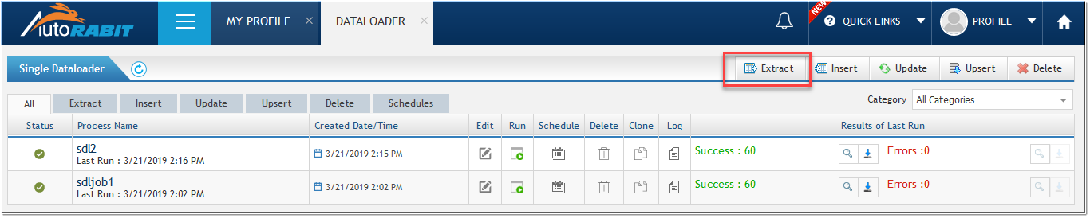

1. In the **Create Extract Process** screen, fill in the details as listed below:

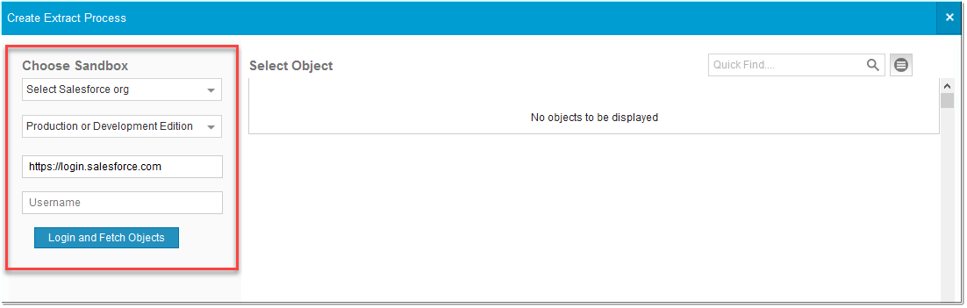

* 1. Select the **Salesforce org**.
  2. Select the **environmen**t i.e., Production or Development Edition, Sandbox or Pre-Release.
  3. The corresponding **URL** and the **username** are automatically generated based on the above selection.
  4. Click **Login and fetch objects.** The list of metadata components related to the Salesforce org gets fetched.

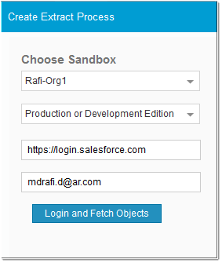

1. Select the object that you want to extract. Click **Next**.

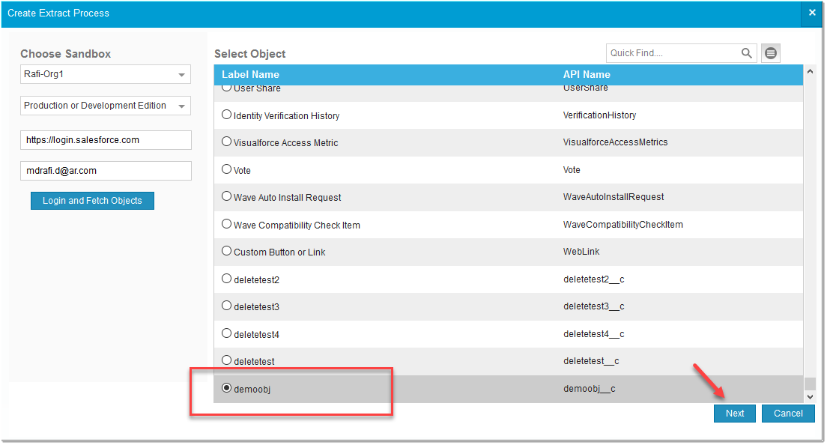

1. In the next screen, select the desired **fields** that will be get extracted for the above selected object. You can search for any specific field using the **Quick Find** search in the top left of the page.

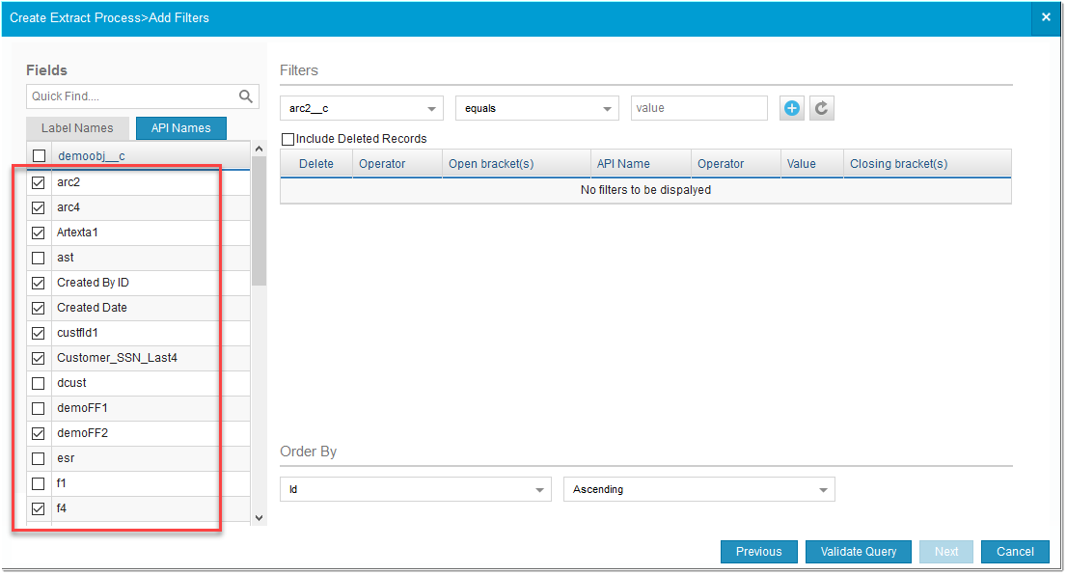

1. Using specifying criteria in **Filters** section, you can extract records within a specified limit.

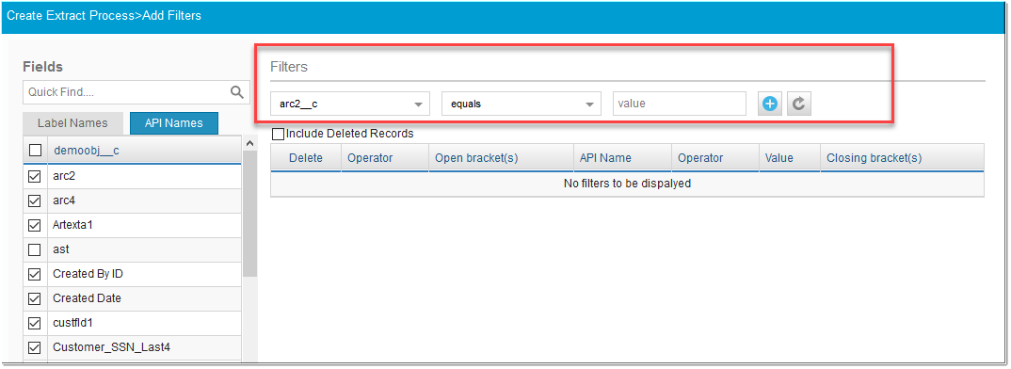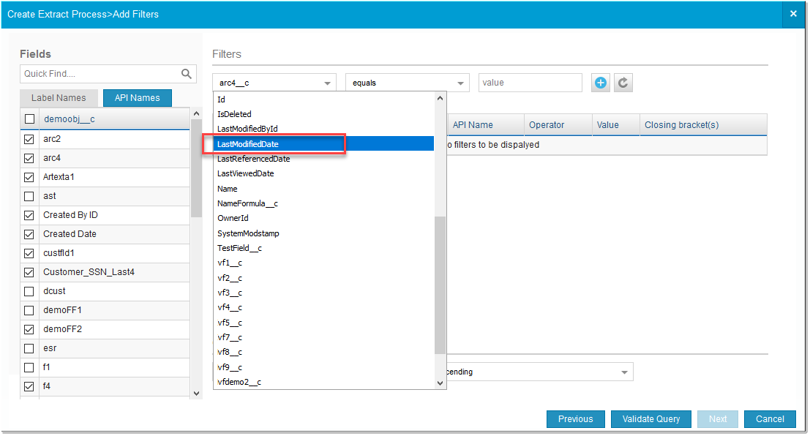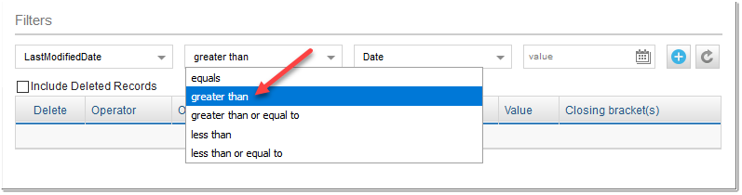

You can specify either a particular **date** or a **date literal**. A date literal is a fixed expression that represents a relative range of time, such as last month, this week, or next year.

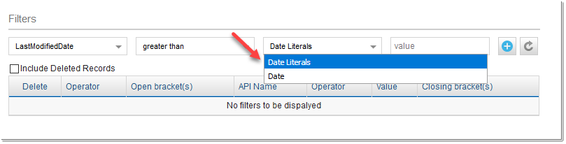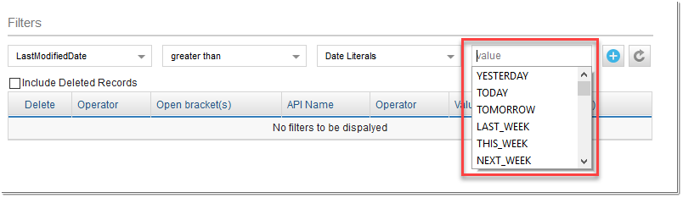

**Date Literals supported**

|  |  |
| --- | --- |
| **Date Literal** | **Range** |
| YESTERDAY | Starts 00:00:00 the day before and continues for 24 hours. |
| TODAY | Starts 00:00:00 of the current day and continues for 24 hours. |
| TOMORROW | Starts 00:00:00 after the current day and continues for 24 hours. |
| LAST_WEEK | Starts 00:00:00 on the first day of the week before the most recent first day of the week and continues for seven full days. Your locale determines the first day of the week. |
| THIS_WEEK | Starts 00:00:00 on the most recent first day of the week before the current day and continues for seven full days. Your locale determines the first day of the week. |
| NEXT_WEEK | Starts 00:00:00 on the most recent first day of the week after the current day and continues for seven full days. Your locale determines the first day of the week. |
| LAST_MONTH | Starts 00:00:00 on the first day of the month before the current day and continues for all the days of that month. |
| THIS_MONTH | Starts 00:00:00 on the first day of the month that the current day is in and continues for all the days of that month. |
| NEXT_MONTH | Starts 00:00:00 on the first day of the month after the month that the current day is in and continues for all the days of that month. |
| LAST_90_DAYS | Starts 00:00:00 of the current day and continues for the past 90 days. |
| NEXT_90_DAYS | Starts 00:00:00 of the current day and continues for the next 90 days. |
| LAST_N_DAYS:n | For the number n provided, starts 00:00:00 of the current day and continues for the past n days. |
| NEXT_N_DAYS:n | For the number n provided, starts 00:00:00 of the current day and continues for the next n days. |
| NEXT_N_WEEKS: n | For the number n provided, starts 00:00:00 of the first day of the next week and continues for the next n weeks. |
| LAST_N_WEEKS:n | For the number n provided, starts 00:00:00 of the last day of the previous week and continues for the past n weeks. |
| NEXT_N_MONTHS:n | For the number n provided, starts 00:00:00 of the first day of the next month and continues for the next n months. |
| LAST_N_MONTHS:n | For the number n provided, starts 00:00:00 of the last day of the previous month and continues for the past n months. |
| THIS_QUARTER | Starts 00:00:00 of the current quarter and continues to the end of the current quarter. |
| LAST_QUARTER | Starts 00:00:00 of the previous quarter and continues to the end of that quarter. |
| NEXT_QUARTER | Starts 00:00:00 of the next quarter and continues to the end of that quarter. |
| NEXT_N_QUARTERS:n | Starts 00:00:00 of the next quarter and continues to the end of the nth quarter. |
| LAST_N_QUARTERS:n | Starts 00:00:00 of the previous quarter and continues to the end of the previous nth quarter. |
| THIS_YEAR | Starts 00:00:00 on January 1 of the current year and continues through the end of December 31 of the current year. |
| LAST_YEAR | Starts 00:00:00 on January 1 of the previous year and continues through the end of December 31 of that year. |
| NEXT_YEAR | Starts 00:00:00 on January 1 of the following year and continues through the end of December 31 of that year. |
| NEXT_N_YEARS:n | Starts 00:00:00 on January 1 of the following year and continues through the end of December 31 of the nth year. |
| LAST_N_YEARS:n | Starts 00:00:00 on January 1 of the previous year and continues through the end of December 31 of the previous nth year. |
| THIS_FISCAL_QUARTER | Starts 00:00:00 on the first day of the current fiscal quarter and continues through the end of the last day of the fiscal quarter. The fiscal year is defined on the Fiscal Year page in Setup. |
| LAST_FISCAL_QUARTER | Starts 00:00:00 on the first day of the last fiscal quarter and continues through the end of the last day of that fiscal quarter. The fiscal year is defined on the Fiscal Year page in Setup. |
| NEXT_FISCAL_QUARTER | Starts 12:00:00 on the first day of the next fiscal quarter and continues  through the end of the last day of that fiscal quarter. The fiscal year is defined  in the company profile under Setup at Company Profile | Fiscal Year. |
| NEXT_N_FISCAL_​QUARTERS:n | Starts 12:00:00 on the first day of the next fiscal quarter and continues through the end of the last day of the nth fiscal quarter. The fiscal year is defined in the company profile under Setup at Company Profile | Fiscal Year. |
| LAST_N_FISCAL_​QUARTERS:n | Starts 12:00:00 on the first day of the last fiscal quarter and continues  through the end of the last day of the previous nth fiscal quarter. The fiscal year is defined in the company profile under Setup at Company Profile | Fiscal Year. |
| THIS_FISCAL_YEAR | Starts 12:00:00 on the first day of the current fiscal year and continues  through the end of the last day of the fiscal year. The fiscal year is defined in  the company profile under Setup at Company Profile | Fiscal Year. |
| LAST_FISCAL_YEAR | Starts 12:00:00 on the first day of the last fiscal year and continues through  the end of the last day of that fiscal year. The fiscal year is defined in the  company profile under Setup at Company Profile | Fiscal Year. |
| NEXT_FISCAL_YEAR | Starts 12:00:00 on the first day of the next fiscal year and continues through  the end of the last day of that fiscal year. The fiscal year is defined in the  company profile under Setup at Company Profile | Fiscal Year. |
| NEXT_N_FISCAL_​YEARS:n | Starts 12:00:00 on the first day of the next fiscal year and continues through  the end of the last day of the nth fiscal year. The fiscal year is defined in the company profile under Setup at Company Profile | Fiscal Year. |
| LAST_N_FISCAL_​YEARS:n | Starts 12:00:00 on the first day of the last fiscal year and continues through  the end of the last day of the previous nth fiscal year. The fiscal year is defined in the company profile under Setup at Company Profile | Fiscal Year. |

1. In **"Order By"** section, you can assign the order in which the record will get generated i.e., either *ascending* or *descending order*.

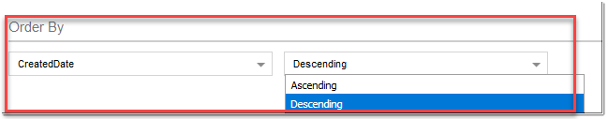

**Note:** For **Kav** objects, ***Language*** and ***Publish Status*** are mandatory fields to be included either to validate or export data. So, whenever Kav object is selected for extracting process, filters on ***Language (value = org default language)*** and ***Publish Status (value = online)*** will automatically added. If want to apply filter with other language and other publish status you can modify the filter.

1. Click **Validate query** to validate your selection. A notification appears that displays the number of records that will be extracted.

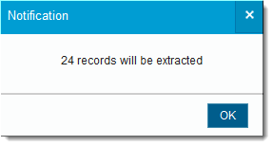

1. Click **Next**.
2. Under **Process Summary** section, give the process a name.
3. Select the **Category**. Categories are used to classify and group similar processes having a similar functionality. In simple terms, you are assigning the similar processes to a category. Either, select an existing Category or create new category by clicking on **'+'** icon.

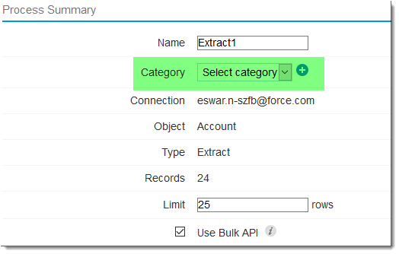

1. Schedule the process by filling in the required details like day, time, and the interval in which the process must run by the Dataloader.

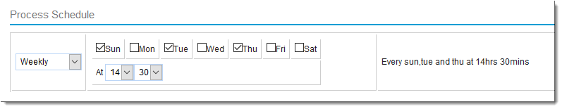

1. Click **Save**. The process is created and gets displayed in the **DataLoader** homepage.

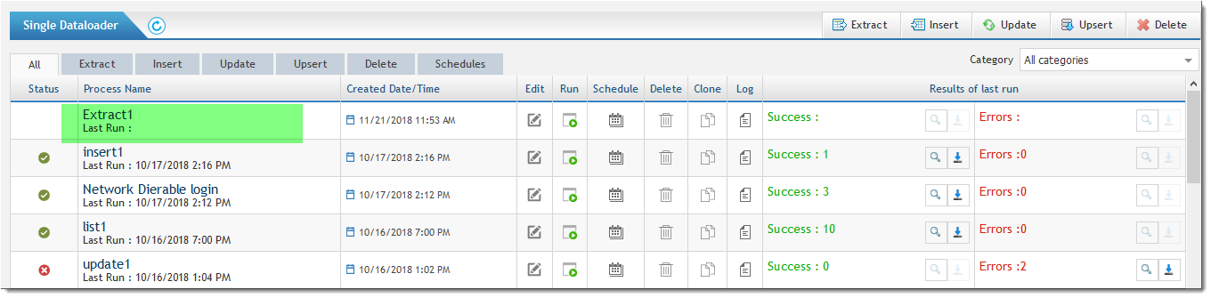

DataLoader Pro: How to migrate Salesforce data to more than one object supporting hierarchy in a single shot?

To migrate the Salesforce data/objects to more than one object supporting hierarchy can be achieved using **Data loader Pro** feature in AutoRABIT. Data loader Pro is an advanced feature provided by AutoRABIT. It is used for transferring data from source sandbox to destination sandbox in a more convenient way and automatically handles the parent-child relationship.

**Features of Dataloader Pro:**

1. Cloud-based Data Loader with scheduling capabilities.
2. Web based tool, so there are no issues of platform dependencies.
3. Supports Circular References.
4. Objects are extracted from source sandbox and transferred to the destination in one step.
5. **Data integrity check**: Checks for data integrity between the source and the destination.
6. **Error reporting**: Detailed reporting of any failure at the time of Dataloader operation.
7. **History of data loading operations**: The results are available as history so that you can view the results in the future.
8. Supports Owner Id transfer.
9. Supports User lookup transfer.
10. Supports Chatter Data migration.
11. Parent-child relationship is preserved.

**Using DataLoader Pro:**

|  |
| --- |
| While performing **Dataloader Pro** on the objects for the first time, make sure you perform **Dataloader Configuration** among same orgs on all the objects included in your Dataloader Pro job. This is a **one-time** operation.  Dataloader plays an important role in data migration from source sandbox to destination sandbox. However, in this process of data migration, chances of duplicate records being created always exists. To avoid this, AutoRABIT has come up with a new feature that allows synchronizing of data between the Orgs with the help of AutoRABIT external id **"AutorabitExtid__c"** field. |

Assuming you login to AutoRABIT, for example, with username **xyz@autorabit.com**, you need to do the following:

1. Go to **Dataloader > Dataloader Pro** and click on **Create New Job** from the right navigation bar.
2. On the next screen, choose the **Source** and **Destination sandboxes** which automatically populate the details of selected sandbox.
3. Click **Login and fetch objects**.

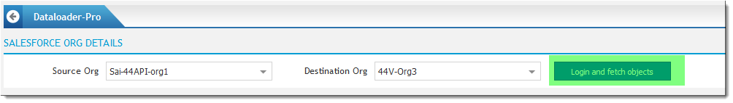

1. Select the **Master object**.

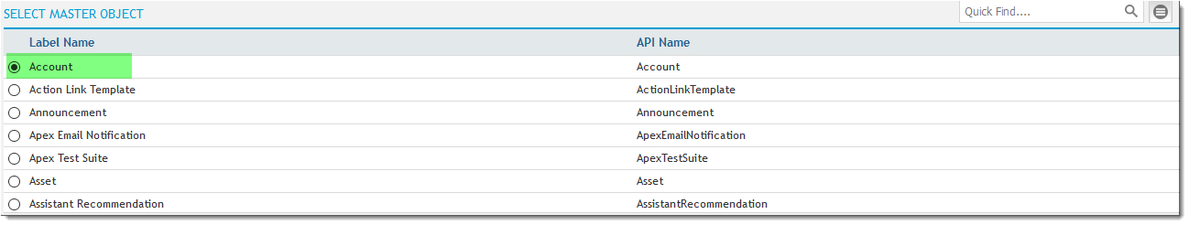

1. View the relationship between child objects/ancestor objects and the master object in **SCHEMA (GRID VIEW)** section.

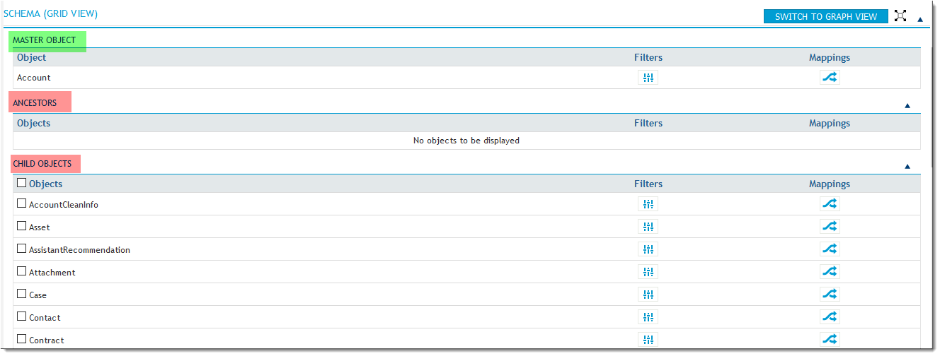

1. Change the grid view to graph view by clicking on .

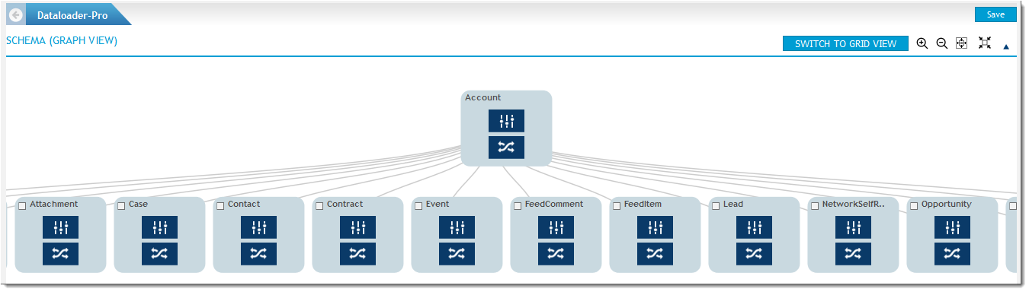

1. For each object displayed, the user can view the list of fields related to the corresponding object. Additionally, there are two options to choose from:
   1. **Filters**
   2. **Mapping**

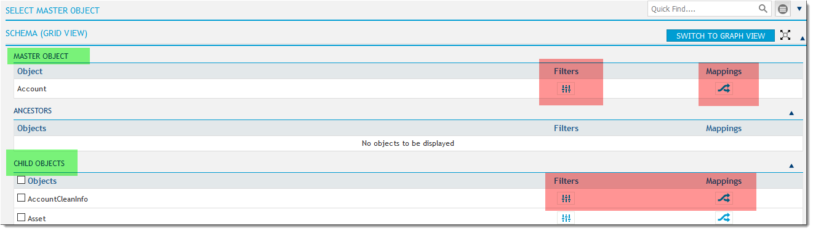

A. Filters

Using specifying criteria in **Filters** () section, you can extract records within a specified limit.



You can specify either a particular **date** or a **date literal**. A date literal is a fixed expression that represents a relative range of time, such as last month, this week, or next year.

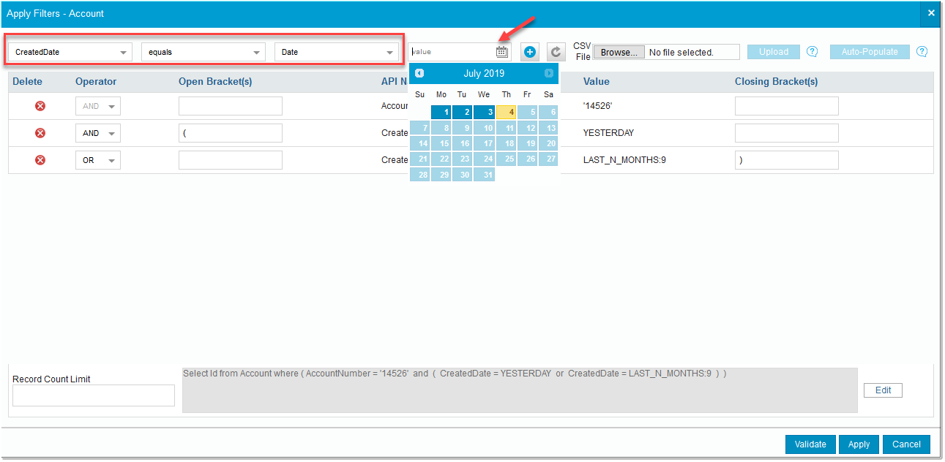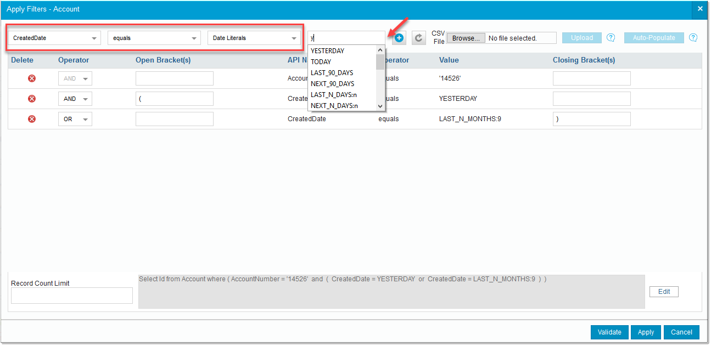

**Date Literals supported**

|  |  |
| --- | --- |
| **Date Literal** | **Range** |
| YESTERDAY | Starts 00:00:00 the day before and continues for 24 hours. |
| TODAY | Starts 00:00:00 of the current day and continues for 24 hours. |
| TOMORROW | Starts 00:00:00 after the current day and continues for 24 hours. |
| LAST_WEEK | Starts 00:00:00 on the first day of the week before the most recent first day of the week and continues for seven full days. Your locale determines the first day of the week. |
| THIS_WEEK | Starts 00:00:00 on the most recent first day of the week before the current day and continues for seven full days. Your locale determines the first day of the week. |
| NEXT_WEEK | Starts 00:00:00 on the most recent first day of the week after the current day and continues for seven full days. Your locale determines the first day of the week. |
| LAST_MONTH | Starts 00:00:00 on the first day of the month before the current day and continues for all the days of that month. |
| THIS_MONTH | Starts 00:00:00 on the first day of the month that the current day is in and continues for all the days of that month. |
| NEXT_MONTH | Starts 00:00:00 on the first day of the month after the month that the current day is in and continues for all the days of that month. |
| LAST_90_DAYS | Starts 00:00:00 of the current day and continues for the past 90 days. |
| NEXT_90_DAYS | Starts 00:00:00 of the current day and continues for the next 90 days. |
| LAST_N_DAYS:n | For the number n provided, starts 00:00:00 of the current day and continues for the past n days. |
| NEXT_N_DAYS:n | For the number n provided, starts 00:00:00 of the current day and continues for the next n days. |
| NEXT_N_WEEKS: n | For the number n provided, starts 00:00:00 of the first day of the next week and continues for the next n weeks. |
| LAST_N_WEEKS:n | For the number n provided, starts 00:00:00 of the last day of the previous week and continues for the past n weeks. |
| NEXT_N_MONTHS:n | For the number n provided, starts 00:00:00 of the first day of the next month and continues for the next n months. |
| LAST_N_MONTHS:n | For the number n provided, starts 00:00:00 of the last day of the previous month and continues for the past n months. |
| THIS_QUARTER | Starts 00:00:00 of the current quarter and continues to the end of the current quarter. |
| LAST_QUARTER | Starts 00:00:00 of the previous quarter and continues to the end of that quarter. |
| NEXT_QUARTER | Starts 00:00:00 of the next quarter and continues to the end of that quarter. |
| NEXT_N_QUARTERS:n | Starts 00:00:00 of the next quarter and continues to the end of the nth quarter. |
| LAST_N_QUARTERS:n | Starts 00:00:00 of the previous quarter and continues to the end of the previous nth quarter. |
| THIS_YEAR | Starts 00:00:00 on January 1 of the current year and continues through the end of December 31 of the current year. |
| LAST_YEAR | Starts 00:00:00 on January 1 of the previous year and continues through the end of December 31 of that year. |
| NEXT_YEAR | Starts 00:00:00 on January 1 of the following year and continues through the end of December 31 of that year. |
| NEXT_N_YEARS:n | Starts 00:00:00 on January 1 of the following year and continues through the end of December 31 of the nth year. |
| LAST_N_YEARS:n | Starts 00:00:00 on January 1 of the previous year and continues through the end of December 31 of the previous nth year. |
| THIS_FISCAL_QUARTER | Starts 00:00:00 on the first day of the current fiscal quarter and continues through the end of the last day of the fiscal quarter. The fiscal year is defined on the Fiscal Year page in Setup. |
| LAST_FISCAL_QUARTER | Starts 00:00:00 on the first day of the last fiscal quarter and continues through the end of the last day of that fiscal quarter. The fiscal year is defined on the Fiscal Year page in Setup. |
| NEXT_FISCAL_QUARTER | Starts 12:00:00 on the first day of the next fiscal quarter and continues  through the end of the last day of that fiscal quarter. The fiscal year is defined  in the company profile under Setup at Company Profile | Fiscal Year. |
| NEXT_N_FISCAL_​QUARTERS:n | Starts 12:00:00 on the first day of the next fiscal quarter and continues through the end of the last day of the nth fiscal quarter. The fiscal year is defined in the company profile under Setup at Company Profile | Fiscal Year. |
| LAST_N_FISCAL_​QUARTERS:n | Starts 12:00:00 on the first day of the last fiscal quarter and continues  through the end of the last day of the previous nth fiscal quarter. The fiscal year is defined in the company profile under Setup at Company Profile | Fiscal Year. |
| THIS_FISCAL_YEAR | Starts 12:00:00 on the first day of the current fiscal year and continues  through the end of the last day of the fiscal year. The fiscal year is defined in  the company profile under Setup at Company Profile | Fiscal Year. |
| LAST_FISCAL_YEAR | Starts 12:00:00 on the first day of the last fiscal year and continues through  the end of the last day of that fiscal year. The fiscal year is defined in the  company profile under Setup at Company Profile | Fiscal Year. |
| NEXT_FISCAL_YEAR | Starts 12:00:00 on the first day of the next fiscal year and continues through  the end of the last day of that fiscal year. The fiscal year is defined in the  company profile under Setup at Company Profile | Fiscal Year. |
| NEXT_N_FISCAL_​YEARS:n | Starts 12:00:00 on the first day of the next fiscal year and continues through  the end of the last day of the nth fiscal year. The fiscal year is defined in the company profile under Setup at Company Profile | Fiscal Year. |
| LAST_N_FISCAL_​YEARS:n | Starts 12:00:00 on the first day of the last fiscal year and continues through  the end of the last day of the previous nth fiscal year. The fiscal year is defined in the company profile under Setup at Company Profile | Fiscal Year. |

a. To add another filter, click on  and fill the required filter criteria.



b. Upload a CSV file if there is large amount of data.

c. Click **Auto-populate** and the filters will be auto-populated for selected field and operator based on the values of selected field in the uploaded CSV file.

d. Select the **operator** (AND/OR).

e. Enter the **Open** or **Close** brackets as needed.

f. In Record Count Limit, enter a value.

g. Click:

i.  **Validate** to validate the entered values or

ii.  **Apply** to directly save the operation.

|  |  |
| --- | --- |
| **Icon** | **Description** |
|  | Browse the .CSV file locally |
|  | Upload the CSV file |
|  | Auto populate the fields which are retrieved from CSV file |
|  | Deletes the filter |
|  | Adds more filter |
|  | Edit the query directly from editor |
|  | Limit field will limit the number of records to be extracted from the source, give a value in this field |
|  | Click **Validate** to get the number of records that will be transferred from the source sandbox to destination sandbox |

**Iconic Representation for Filter**